Think about…
Talk about…

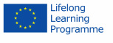
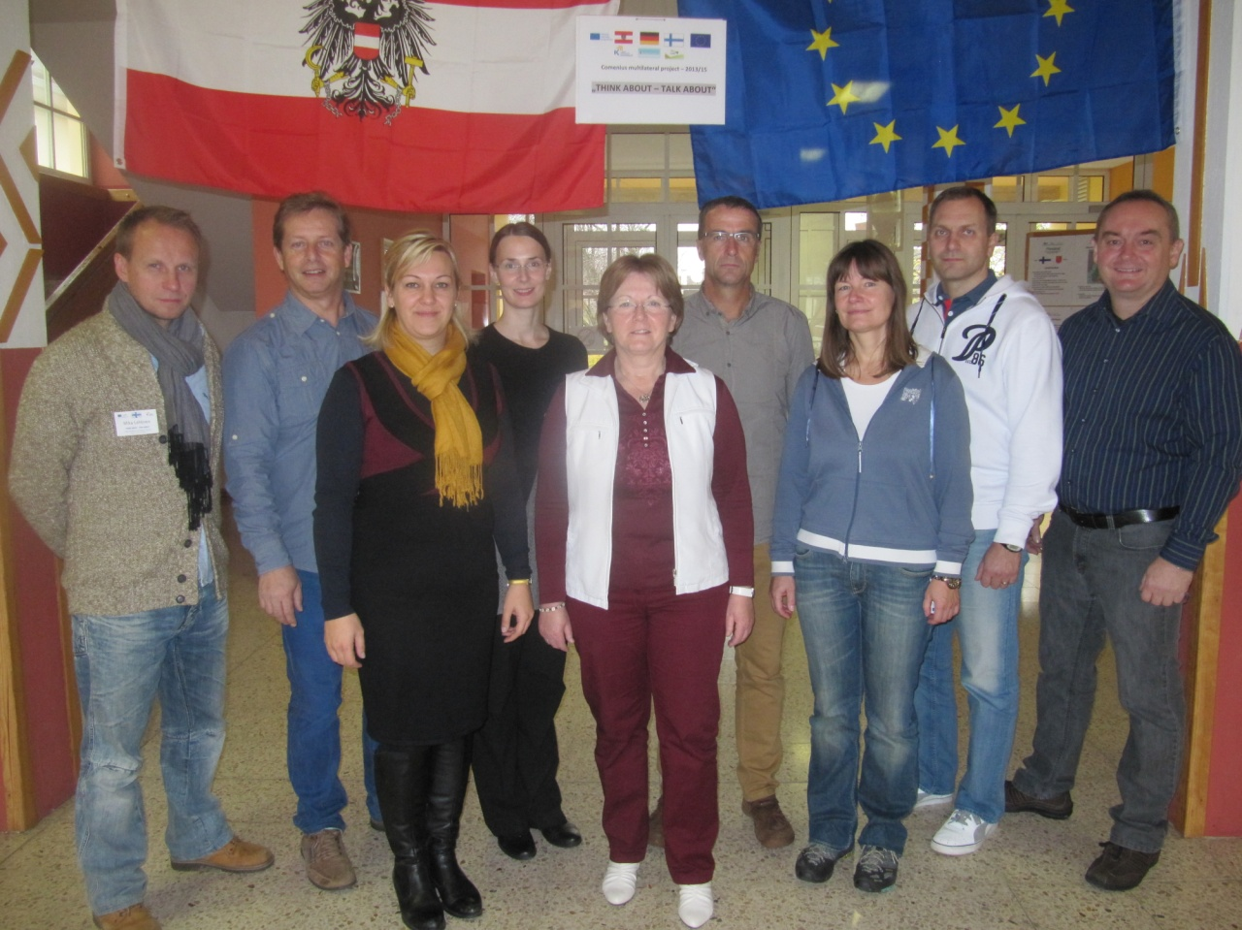
Three partners (Finland, Germany and Austria) were approved. Portugal the 4th partner was not approved. Austria became the new coordinating school for the project. The partnership started with a Preparatory Meeting in Eisenberg/Thüringen, Germany. We started contacting each other by email and we began preparing PowerPoint Presentations about the partner countries.

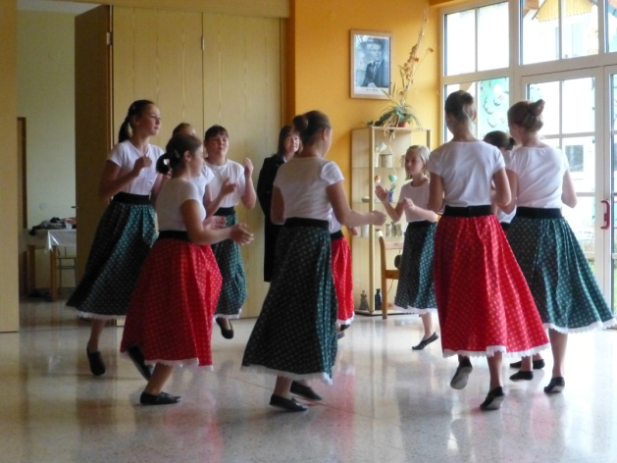
From the 9th to the 15th November 2013, the three partner countries (Austria, Germany and Finland) of the Comenius project Think about…Talk about.., attended the first meeting in Kohfidisch, Austria, at Neue Mittelschule Kohfidisch.

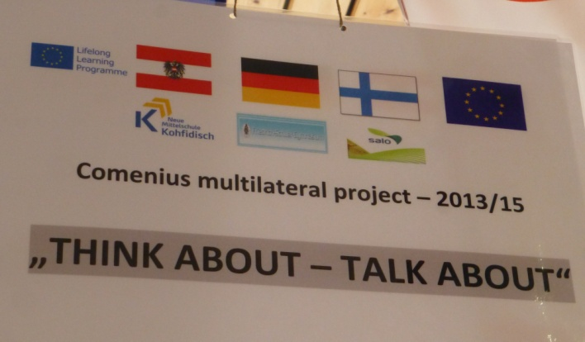

The main aim of this project meeting was to prepare all the activities for the upcoming students´ meeting in Finland in April 2014.
At this meeting we had the opportunity to bridge three countries by learning about different cultures, habits, traditions, life styles and school systems, which gave us teachers the chance to get to know each other better.
During our stay in Kohfidisch we prepared project tools, like a questionnaire, the working plans for the first students’ exchange which contains the setting up of a European corner.
On this occasion we were taught how to use the platform “www.lms.at”.
The teachers created an “Action plan” for the next students´ meeting in Finland in April:
Students from the three countries will design a logo for the project “Think about…Talk about…” in their own schools and bring the best three to Finland. There will be a logo contest. The winner logo will be the project logo during the whole project time and used on each document on- and offline.
The students will present their own country. Content of the presentation will be: country, region, school and subjects.
The results will be added in each schools´ European Corner.
The statistics of the survey will be presented, be discussed and the students will draw a conclusion for the ongoing working activities.
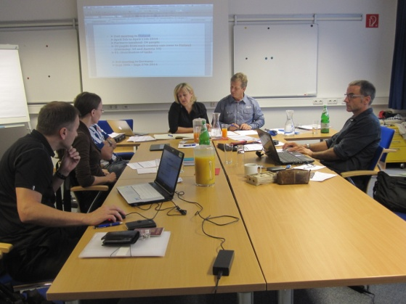
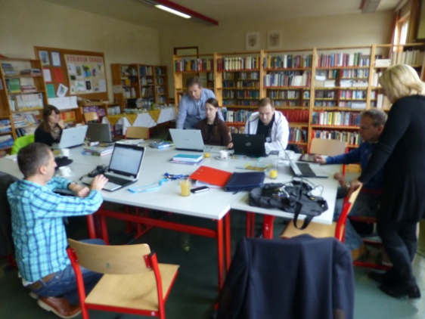
In Finland the students are going to show their progress in:
- introducing presenting their countries,
- educational systems,
- the results of the survey and
- draw some conclusions for getting an idea for the next steps.
Therefore pupils will be divided into four groups. Teachers are going to compare the results of the students’ activities by an online evaluation during the first year of the project. They will also arrange the next project meeting in Germany.

The host school NMS Kohfidisch arranged excursions to Vienna, South Burgenland and West Hungary. Teachers learned a lot about the region and were given the chance to get to know its traditions (wine baptism, Saint Martin’s festival, folk music, typical dishes).
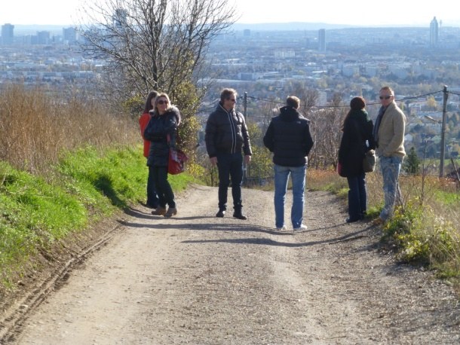
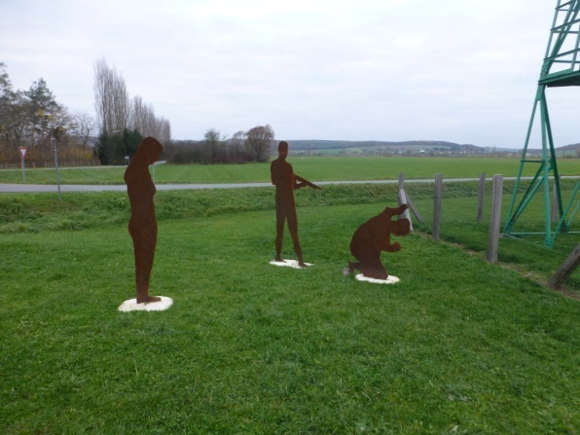

All the partners were glad to attend this project meeting and would like to thank the Austrian partner and all the institutions for their hospitality as well as their cooperation and support for this Comenius Project.
Teachers are also very thankful to all the National Agencies who gave us the opportunity to participate in this project.

