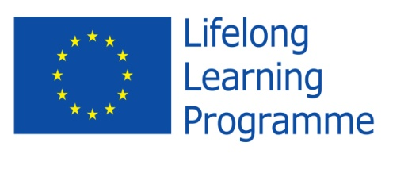

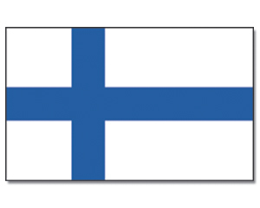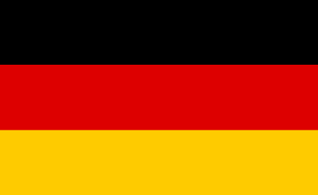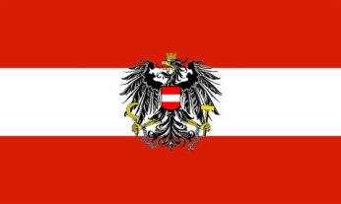

**Project Meeting**

**in**

**Vienna - Austria**

**April 19th - April 24th**

**2015**

**“THINK ABOUT … TALK ABOUT…”**

**supported by EU**

The partner countries attended the fourth meeting of the project in Vienna, Austria from April 19th to April 24th 2015.

All students stayed in the Jufa Hotel in Vienna.

The aims of this meeting were:

* The students did research on producing energy in their country .
* They presented the school result in the youth conference. They were sharing the results with the partners concerning the energy producing situation, renewable energy and Green Jobs. For their presentations they used different ICT tools, like “pretzi”, E-Book and Power Point.
* Working in groups to the topics: Green jobs, renewable energy. Additionally to this we went to the Technical Museum and the Museum of Natural History, to the Waste to Energy Plant and to a Windpower Station to support the gained information .
* As a result of all those activities the students worked in international groups and answered questions asked on padlet.
* In the following the students found out more about Green Jobs in the internet and summarized their findings on a poster and presented it.
* All the meeting products are uploaded on the website <http://thinkabout.talkabout.weebly.com>

April 19th, 2015

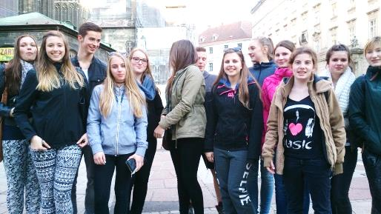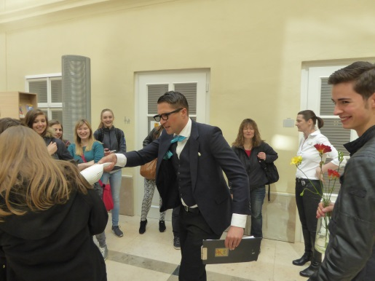On Sunday all participants arrived in Vienna. The German and Finish students and teachers went by plane and the Austrians took the bus. Everybody met in the hotel and had lunch together.

To get a first impression we went to the inner city and took a little tour in the centre. After that we went to “Time Travel” and got a lot of information about the Austrian history from the 15th up to today. Our interest lay on the monarchy of the Habsburger and the Austrian Republic. We went for dinner to catch up.

**April 20th, 2015**

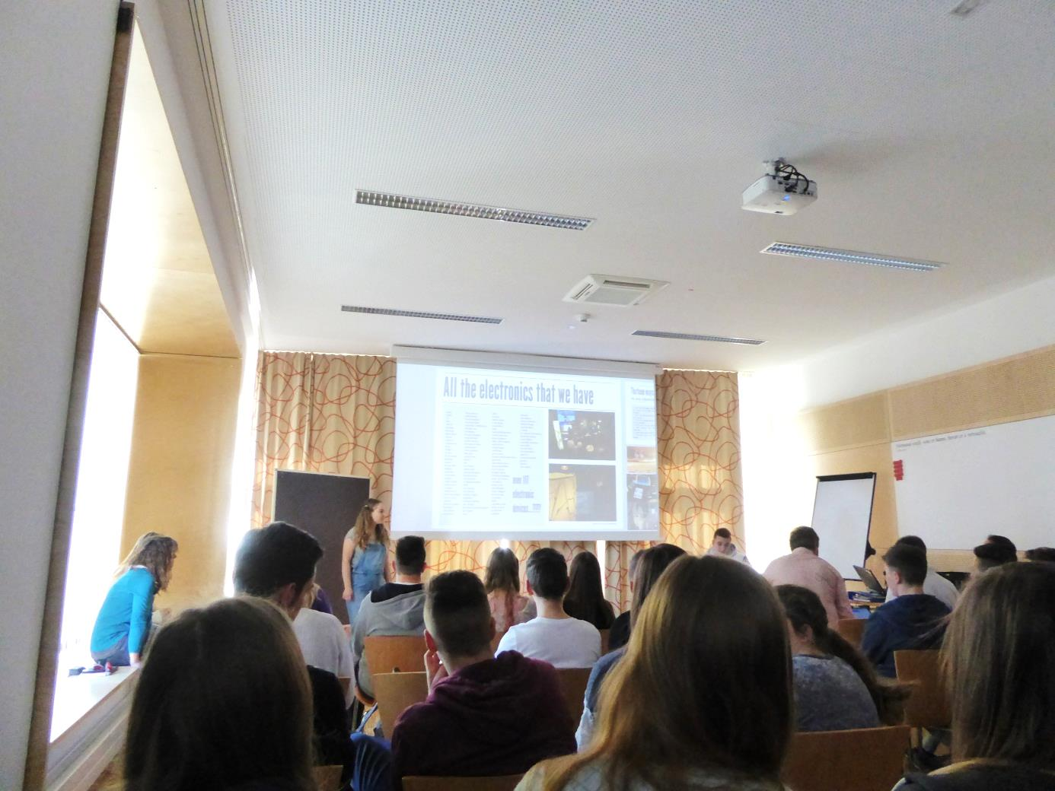On Monday each nation presented their results of their work from the past weeks in our youth conference.

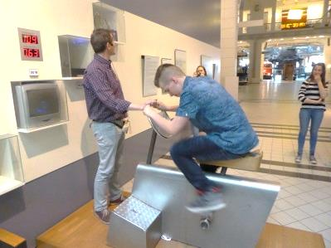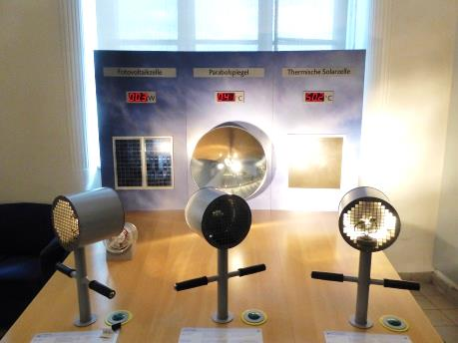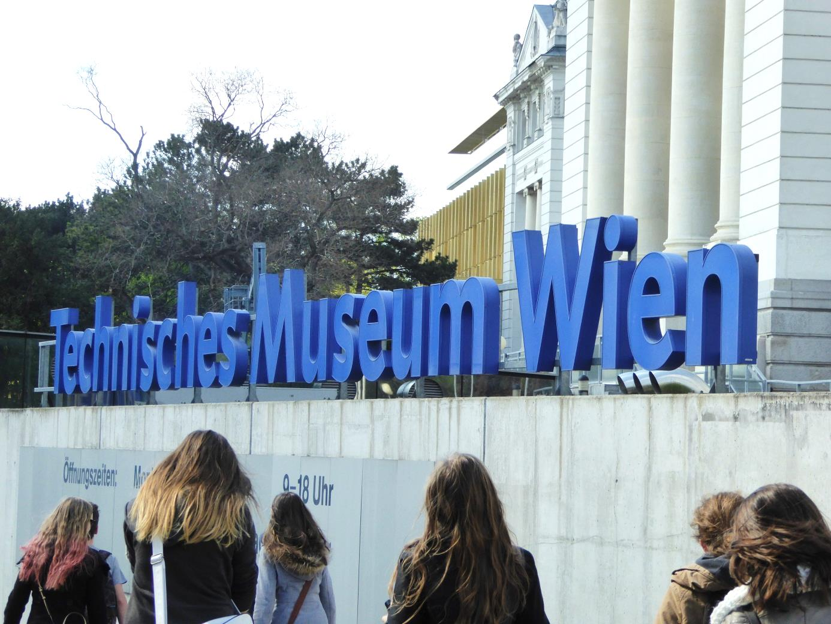

In the afternoon we went to the Technical Museum and joined a guided tour “From Manpower to Electricity”.

The last stop of that day was the castle of Schönbrunn.

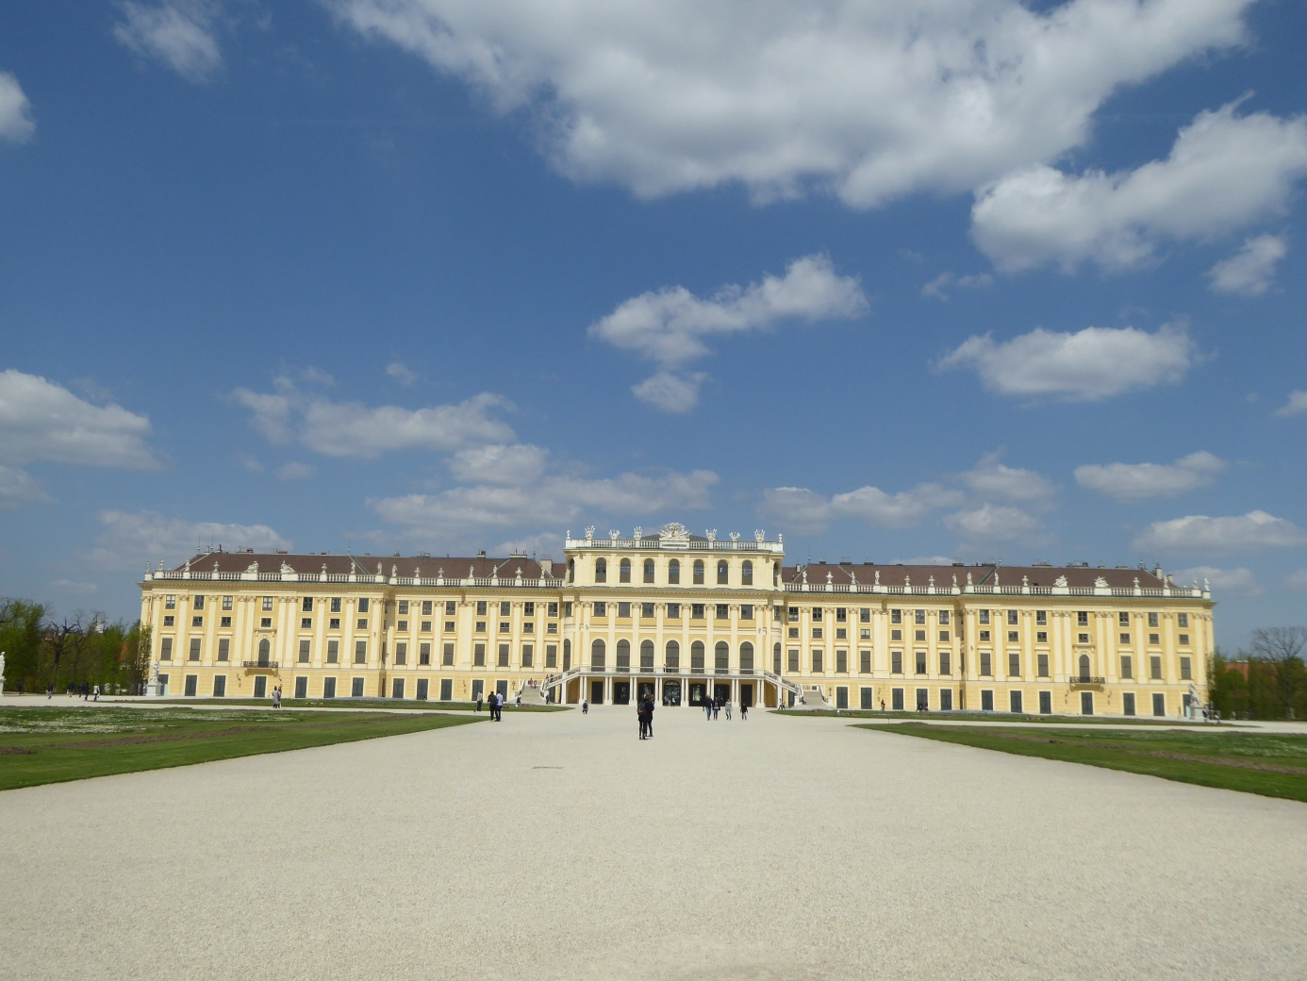

**April 21st, 2015**

In the morning the students did a Town Rallye through the old city centre, were they had a map and tasks to do.

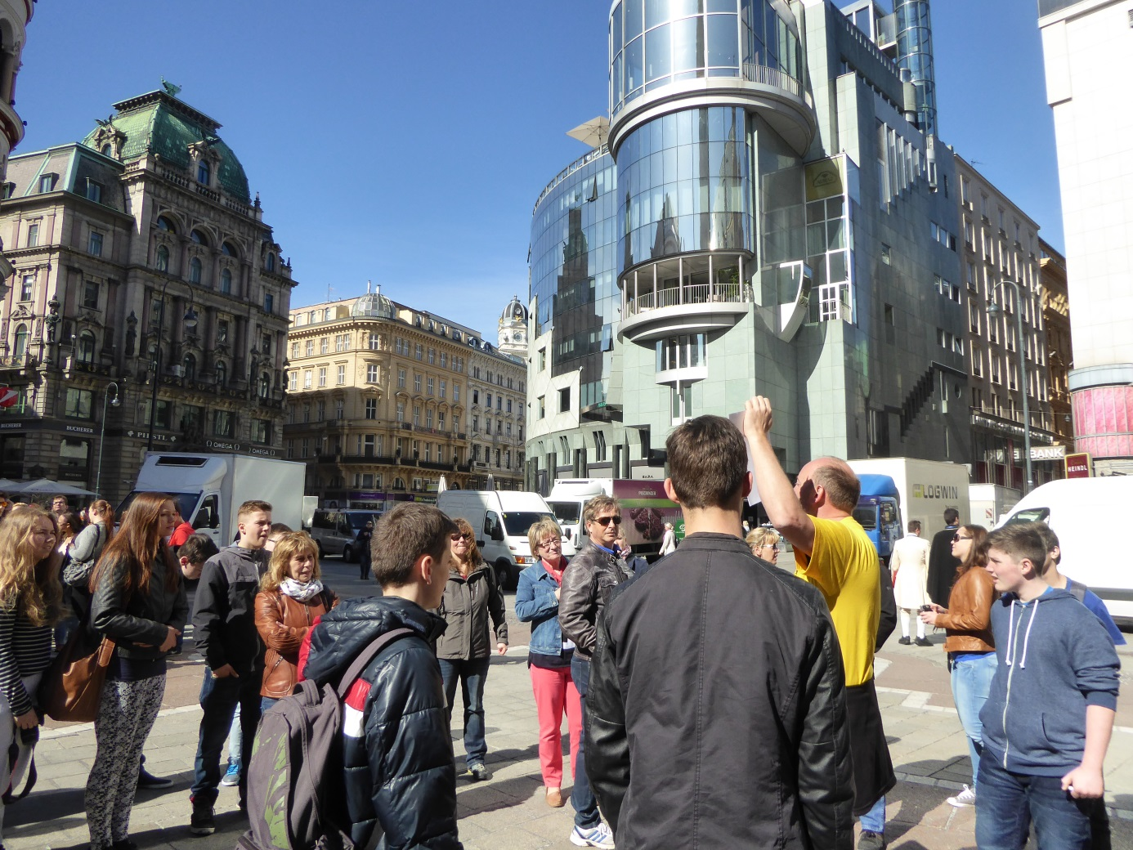

After a common lunch at Pizza Bizi we went to the Waste to Energy Plant in Spittelau, which was designed by the famous Hundertwasser.

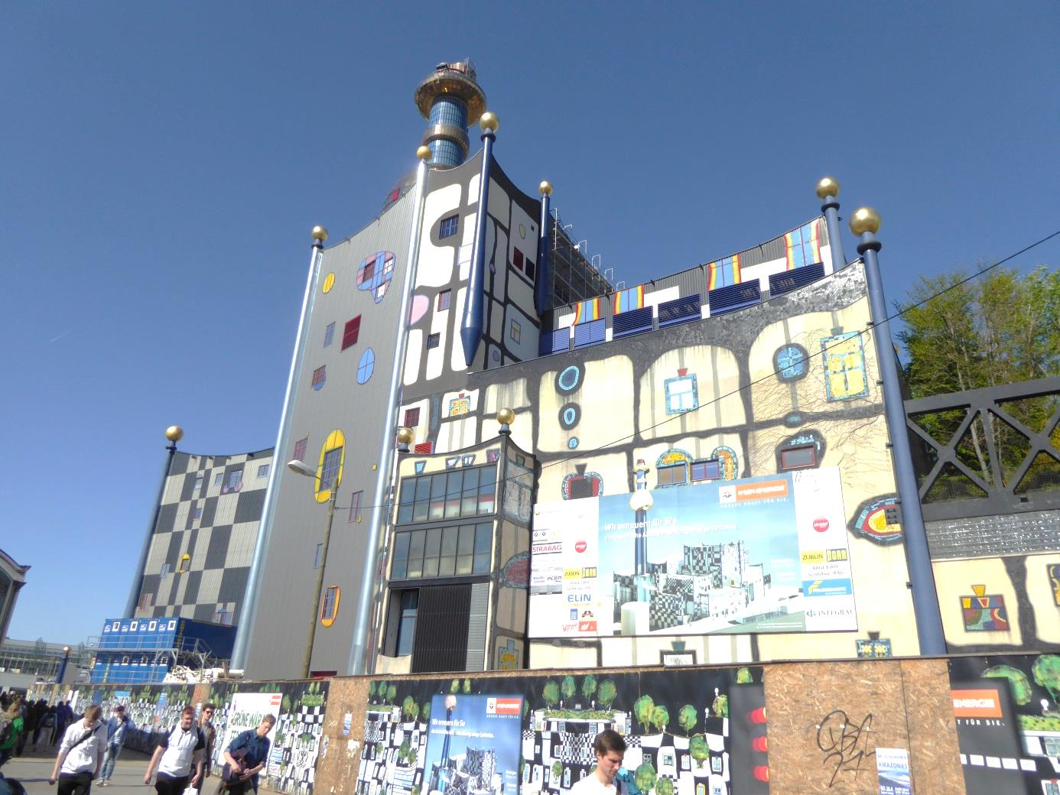

There we had a guided tour about the topic of producing heat and cold energy with the help of burning waste. The power plant was reconstructed and will start working again in June with a higher efficiency.

**April 22nd, 2015**

We started the day visiting the wind power station.

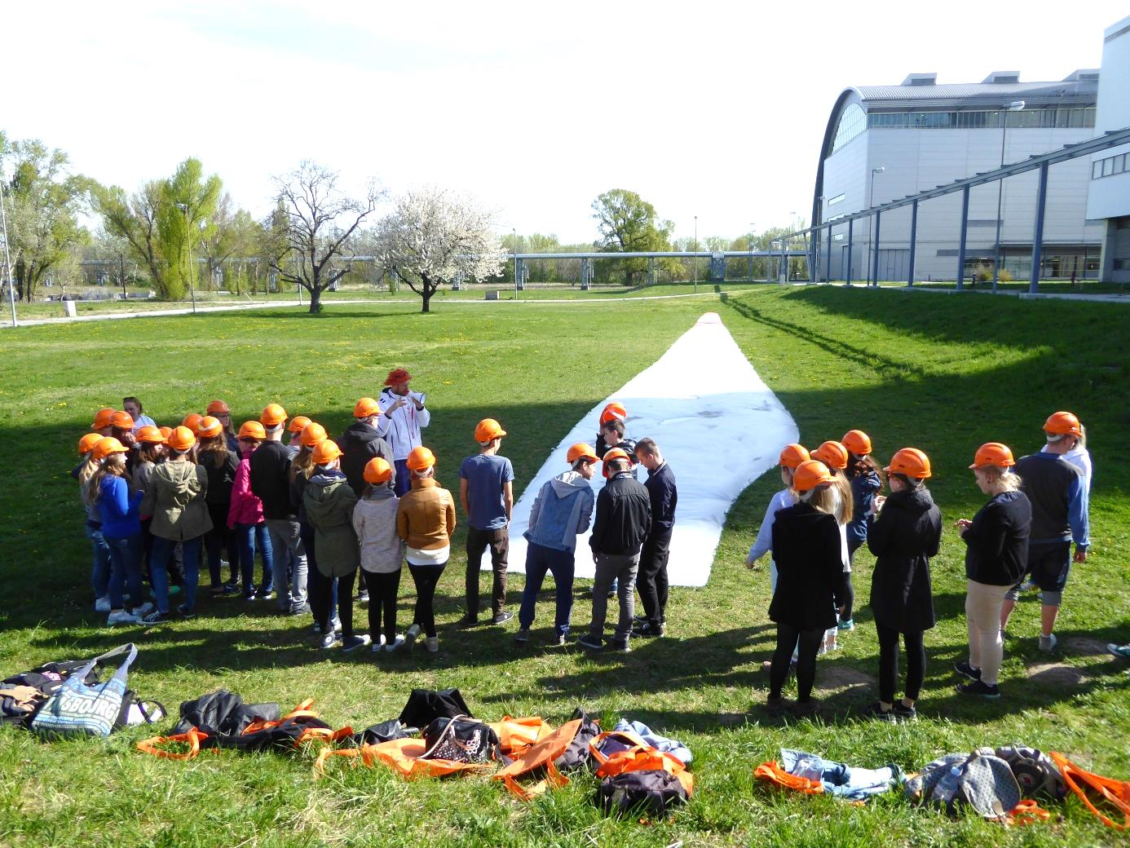

In the afternoon we continued the youth conference.

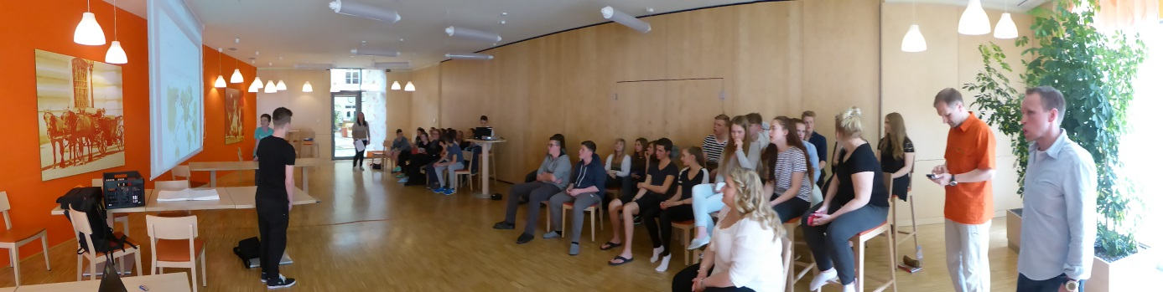

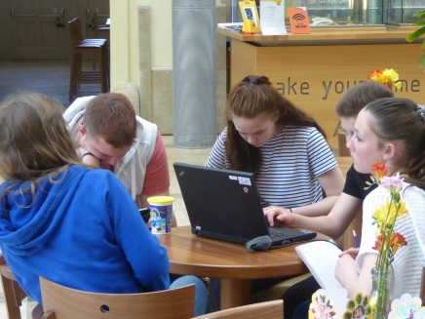 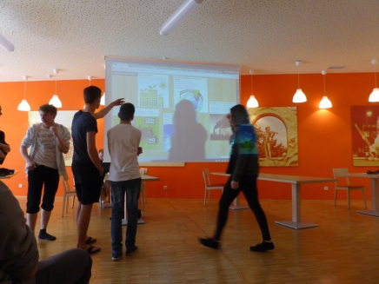 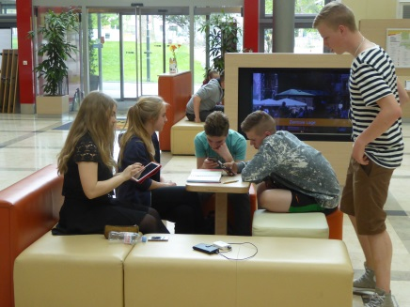

We ended the day with the musical “Mama Mia”

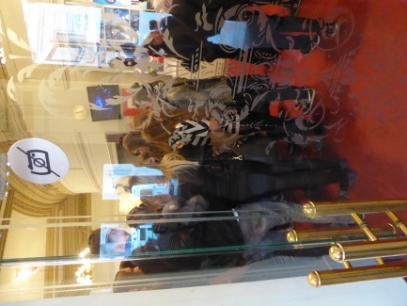 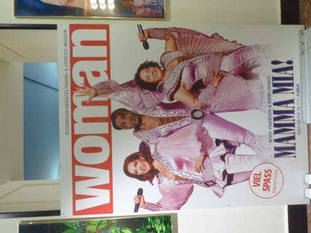  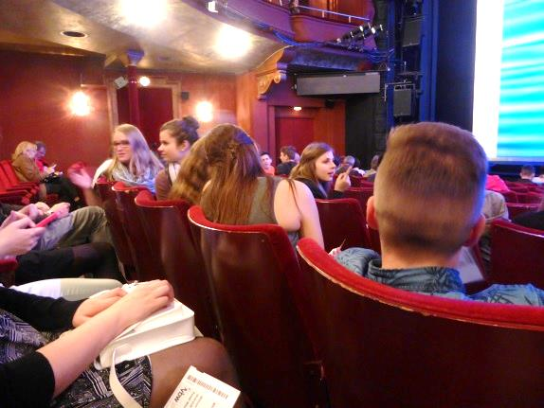

**April 23rd, 2015**

In the morning we continued working on the project of the topic >green job<. The students finished their posters where they showed the profile and the tasks of these professions.

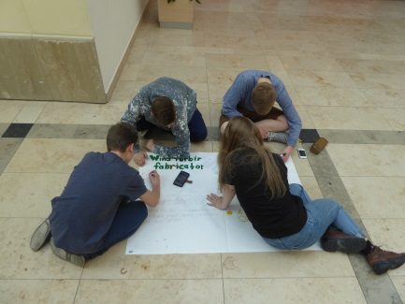 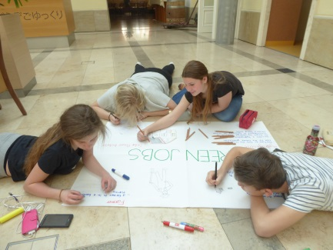 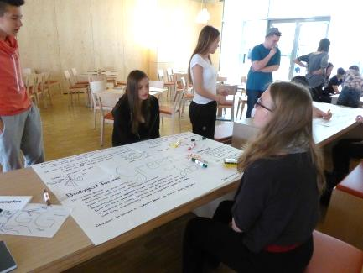

After lunch we went to the Museum of Natural History to get information to the topic of the climate change. We learned a lot about the ice ages and their reasons for their existence. Quite famous is the part the human being plays and its responsibility on the earth and the climate change.

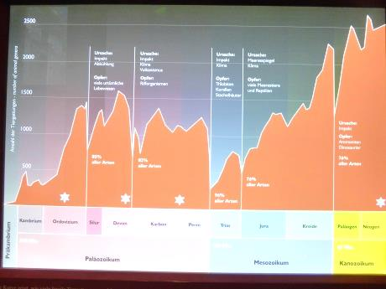 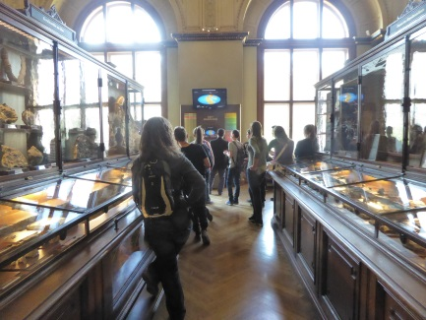 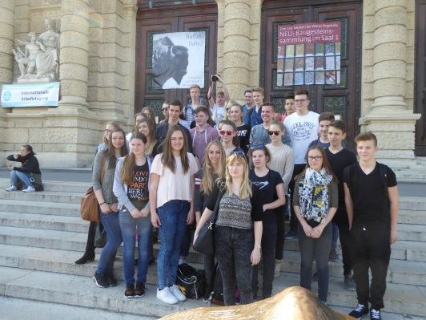

That was an excellent summary of all the places of this week like the Technical Museum and the topic “From Manpower to Electricity”, the Waste to Energy Plant and the Wind Power Station.

The surprise of that day was the Prater, which was the great ending of the week of hard working.

The most favorite things were the giant roller coasters, the big wheels and other attractions.

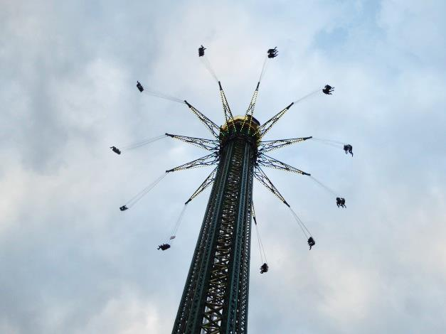 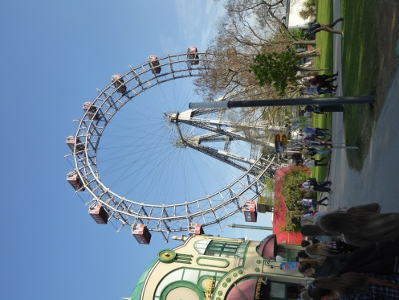 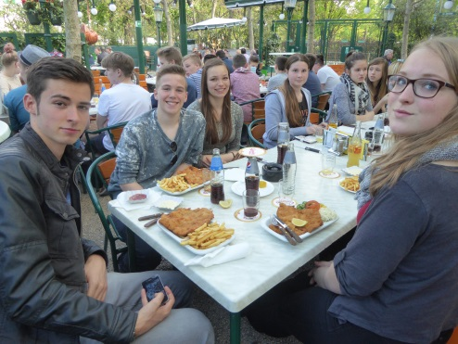

**April 24th, 2015**

It was the time of the final ceremony. The students present their posters where they showed the profile and the tasks of these professions. They discussed about the things they have to do at school.

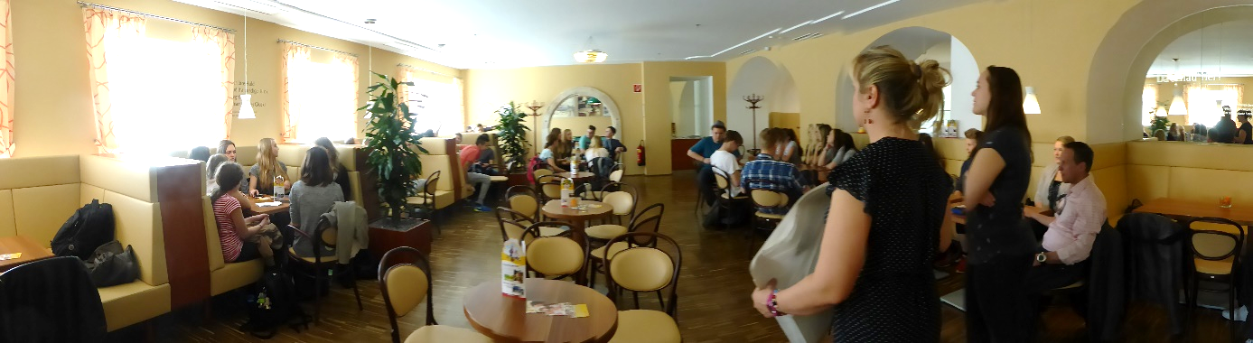

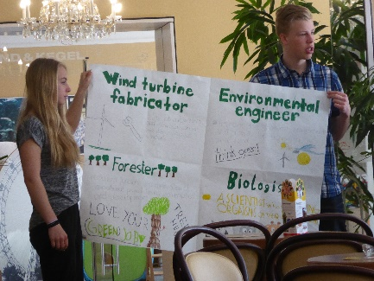 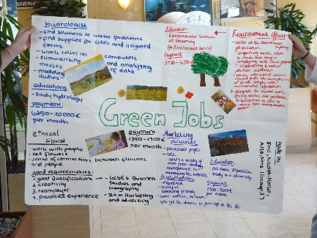 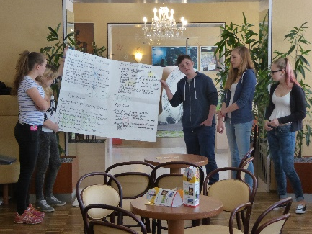

The students got their certificates.

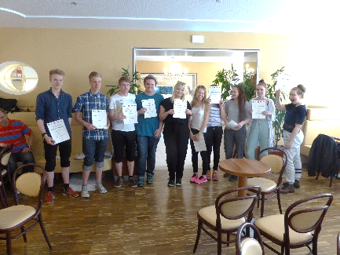 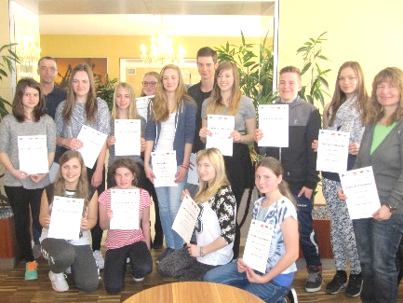 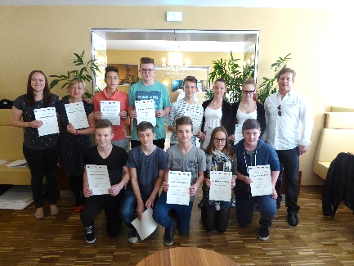

Team Finland Team Germany Team Austria

Than it was time to say Good Byes.

