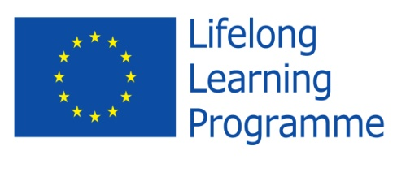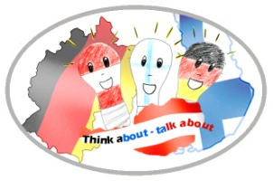

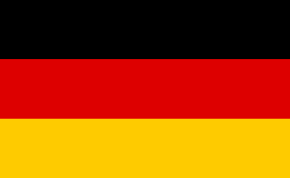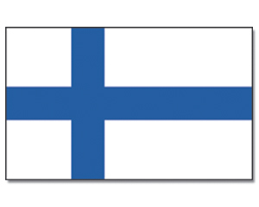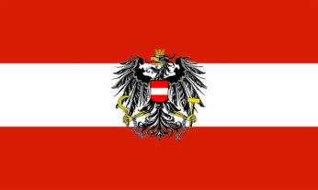

**Project Meeting**

**in**

**Eisenberg - Germany**

**Nov 8th - Nov 14th**

**2014**

**“THINK ABOUT … TALK ABOUT…”**

**supported by EU**

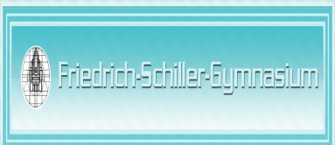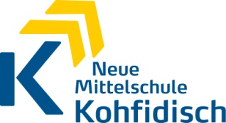

The partner countries attended the third meeting of the project in Eisenberg, Germany, Friedrich Schiller Gymnasium from November 8th to November 14th 2014.

All students were hosted by German families.

**November 8th, 2014**

On Saturday the German Comenius Group went to Leipzig to pick up their Austrian partners. We all continued to Berlin to meet the Finish group. Now we went on. Our final destination was the city center.

It was the day before the 9th of November. Everything was prepared for the great event on the next day: It was the "25 years Mauerfall".

We were lucky to get the chance to visit the Reichstag and to have a walk around the Brandenburg Gate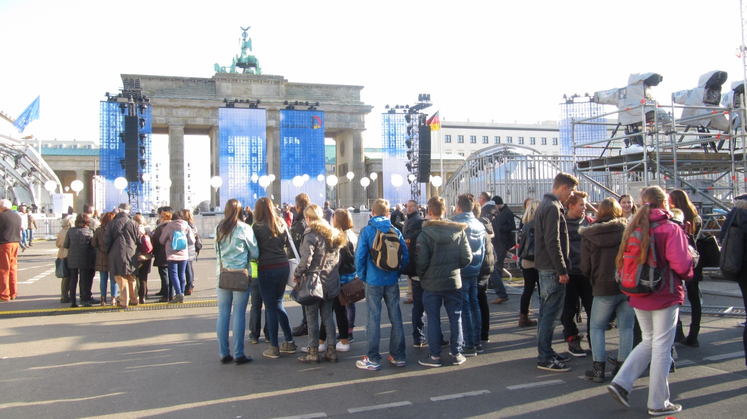.

The aims of this meeting were:

* present the school result. They were sharing the results with the partners concerning the asked questions to the topic. They used difference ICT tools for their presentations.
* Presenting the "Before-After documentation". What each partners could change in their surroundings
* Working in groups to the topics: Mobbing, Bullying, Ecological Footprint, group work how students feel at the beginning and at the end of the meeting.
* In a presentation each group showed us its results.
* They produced films in teams with their mobile phones. The aim of the films were how to avoid and how to act in a correct way when somebody is bullied.
* All the meeting products are uploaded on the website <http://thinkabout.talkabout.weebly.com>

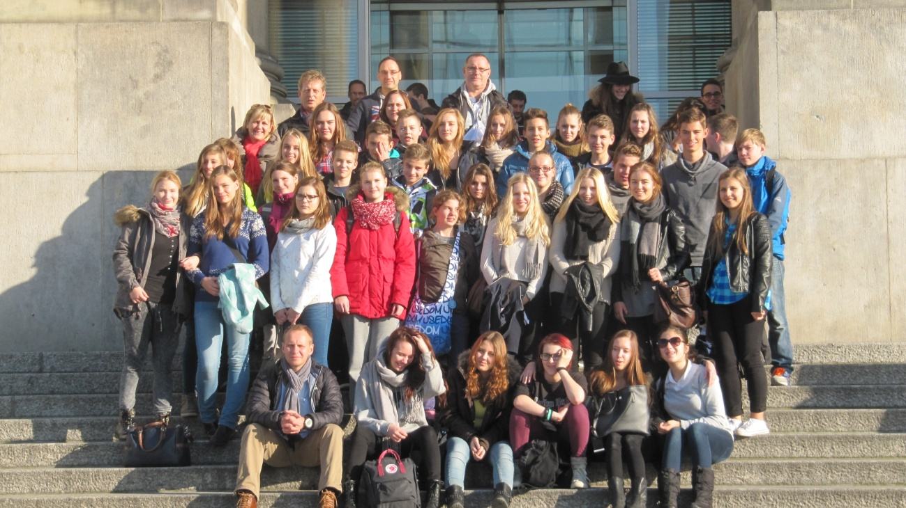

**November 9th, 2014**

The Sunday belonged to the host families and they had their individual programs.

The teachers of the project had a meeting about the weeks´ program and were checking the details.

After that the hosts took the teachers to Jena and to Leuchtenburg and got information about the history of the region Thüringen.

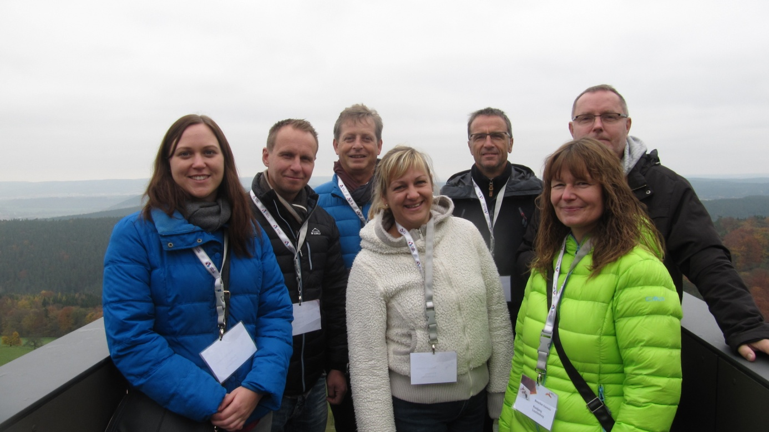

**November 10th, 2014**

Monday was the first day at school. We got a very warm welcome at the grammar school in Eisenberg.

The Germans prepared a program for us. That was really great.

Afterwards we made a tour through the huge school building.

Then work started.

Each nation presented what was done after leaving Finland in spring.

In the afternoon we got an impression of the town. We did a rally.

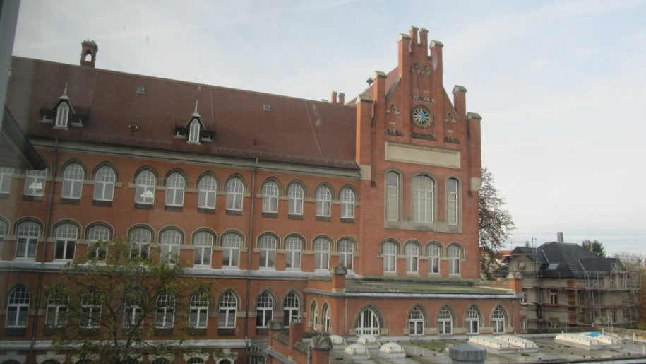

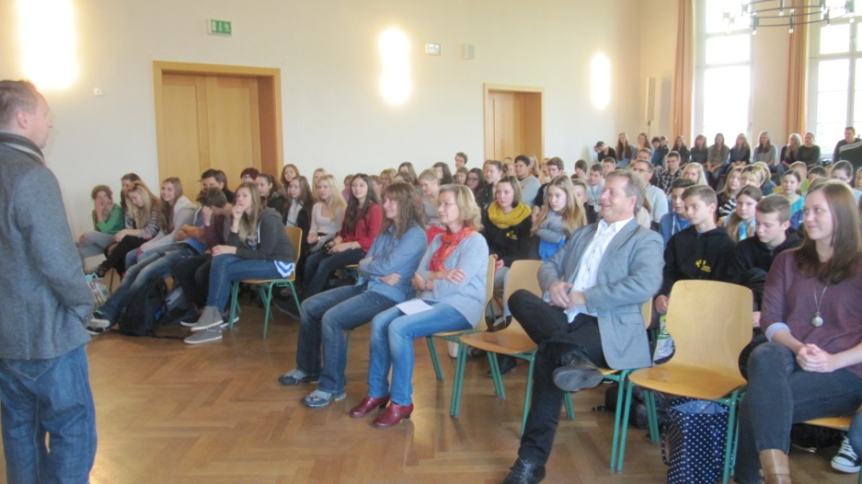

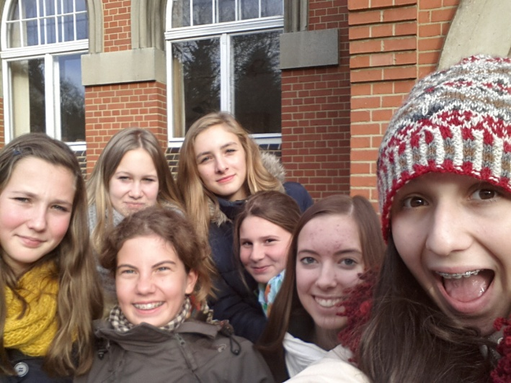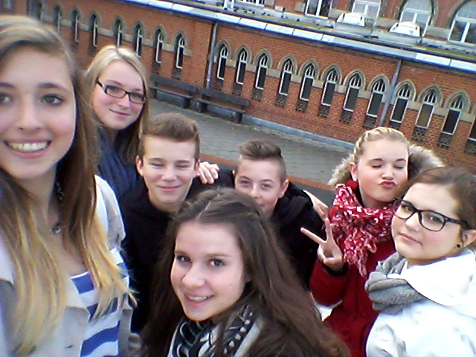

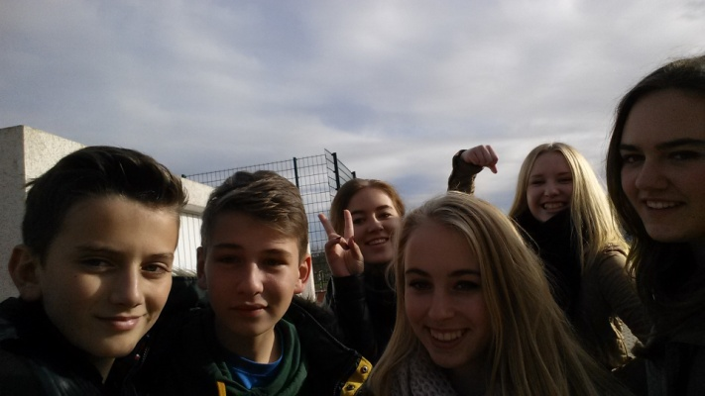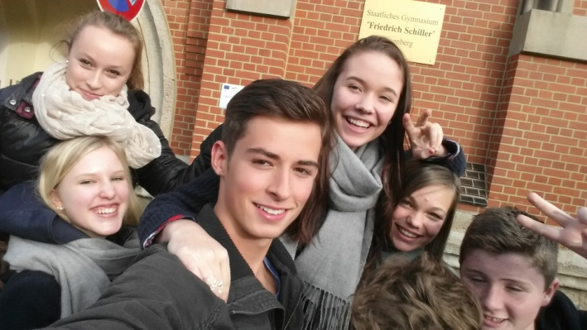

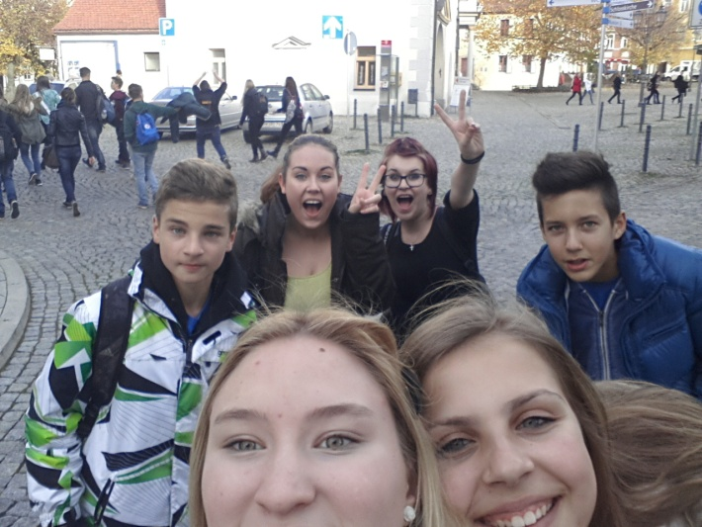

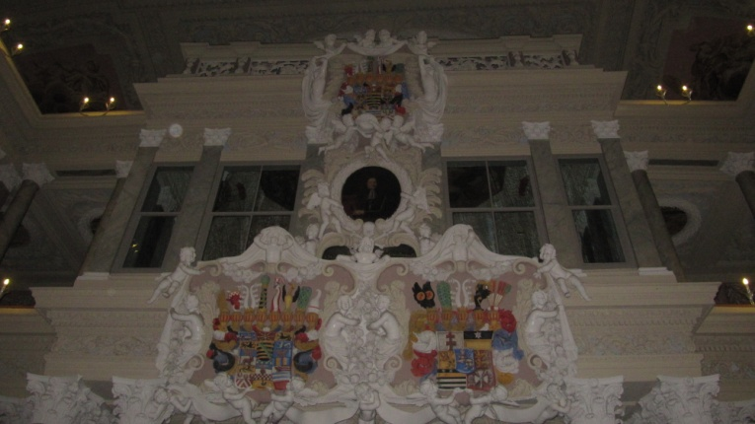

**Tuesday**

**November 11th, 2014**

On the second working day we met at 8.30 in the Aula. There we started our work on the topic of the ecological footprint. Each of us did a survey to find out how "green" he was.

Then we worked in international groups and found at least three things we can do to protect Mother Earth.

We were lucky to join at 11.11 am which is the start of the annual carneval. The students of the Friedrich Schiller Gymnasium prepared a great opening-show

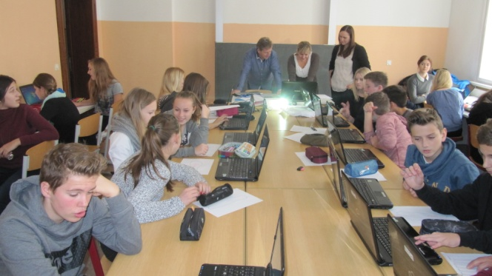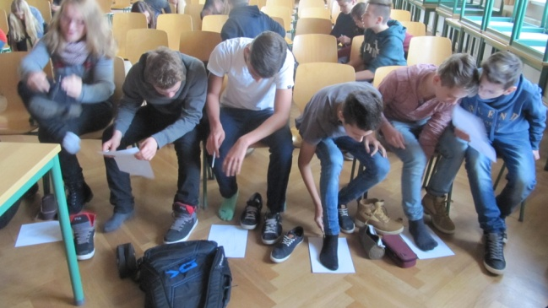

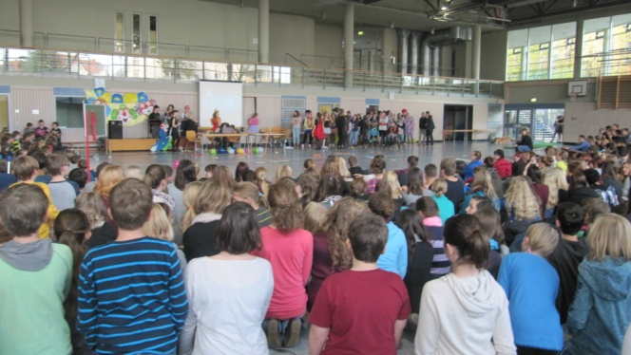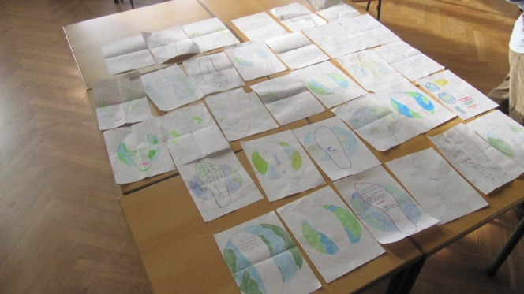

**Wednesday**

*November 12th, 2014*

*Let's go to Erfurt. That was our excursion day.*

*Arrived in the county capital teacher of the grammar school showed us around. Especially interesting was the Fischmarkt and the historic bridge Krämerbrücke. While passing it we noticed how many small and interesting shops there were.*

*Additionally, we learned facts about Martin Luther, passed the old part of the university and heard about the Jewish treasure.*

*After having lunch we got free time before we went back to Eisenberg.*

*Unfortunately the weather was not really nice but nevertheless it was a wonderful day.*

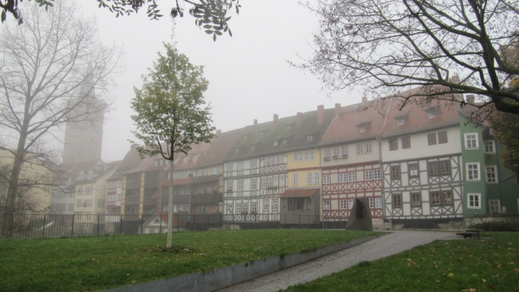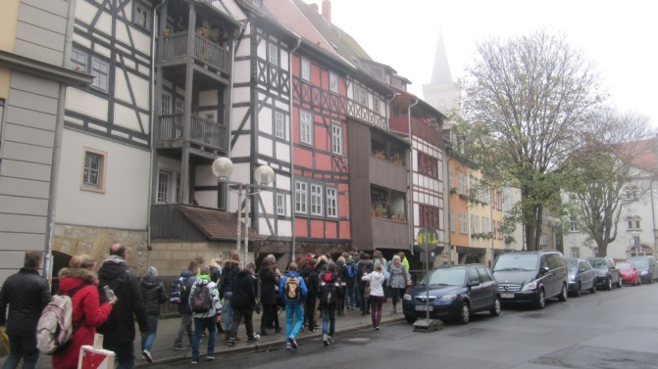

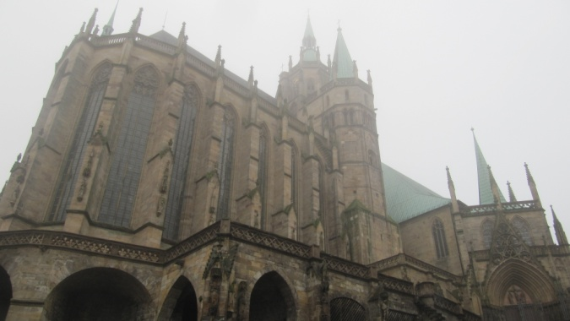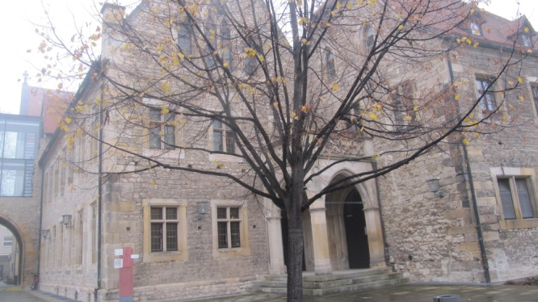

**Thursday**

*November 13th, 2014*

*It´s quiz time!*

*How much do you know about Finland, Germany, Austria and the EU?*

*The students were looking for these information on the internet website:* [*http://kids-corner.eu*](http://kids-corner.eu)

*They formed 5 groups of 6(each nation 2 students. They chose 4 questions and were asking each other. The winning team with all correct answers got a prize.*

*After that they started watching the film "We feed the world". The main aim is to let the students know that they have to take care of their ecological behavings: Not to waste the food and to be aware that millions people are starving all over the world.*

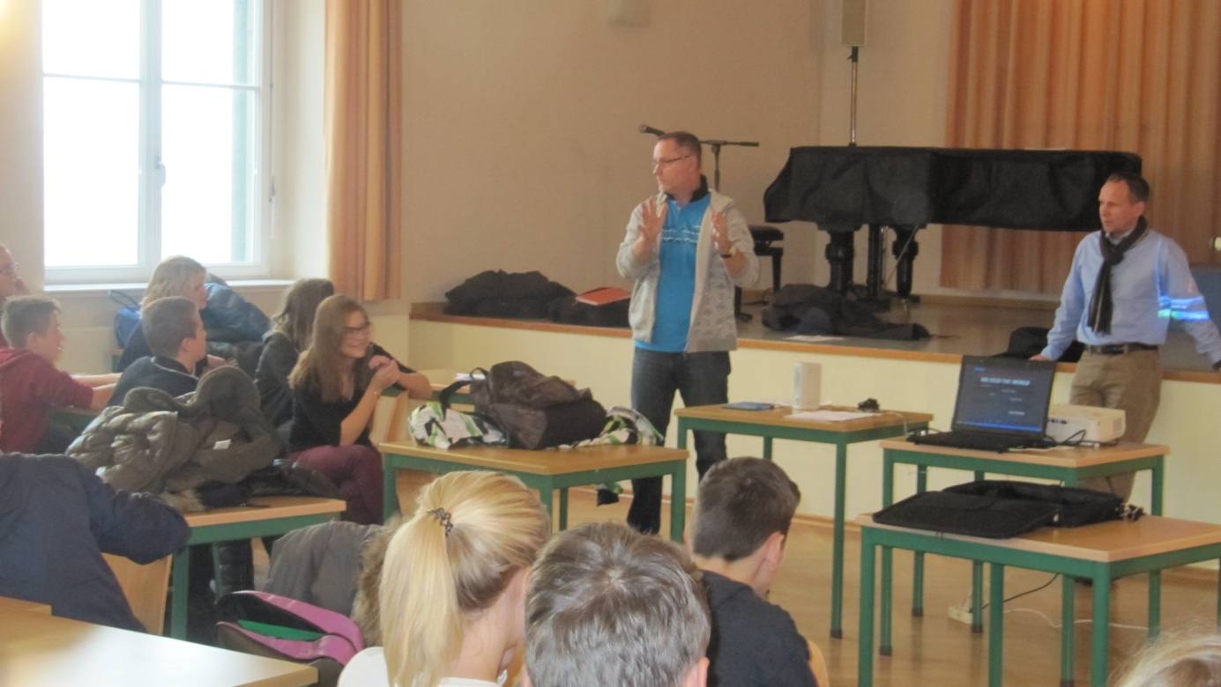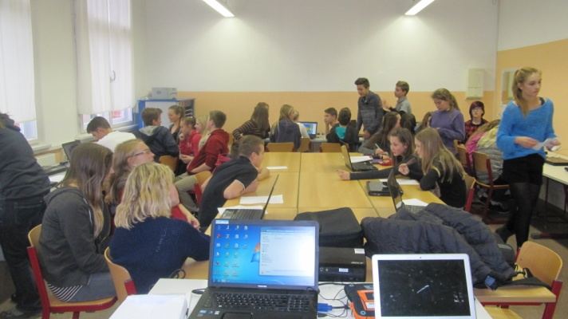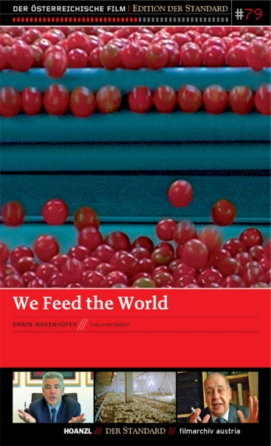

**Friday**

*November 14th, 2014*

In the ongoing working process the students were presenting their group results. They gained knowledge by using their improved ICT skills.

* Groupwork how students feel at the end of the meeting.
* Feedback: Students and teachers evaluation online. Talking about the results.

The teachers talked about the next project meeting in Austria 2015 where they are going to plan the activities for the last year of the project.

All the partners were glad to attend this project meeting and would like to thank the German partners, host families and all the institutions for their hospitality as well as their cooperation and support for this Comenius Project.

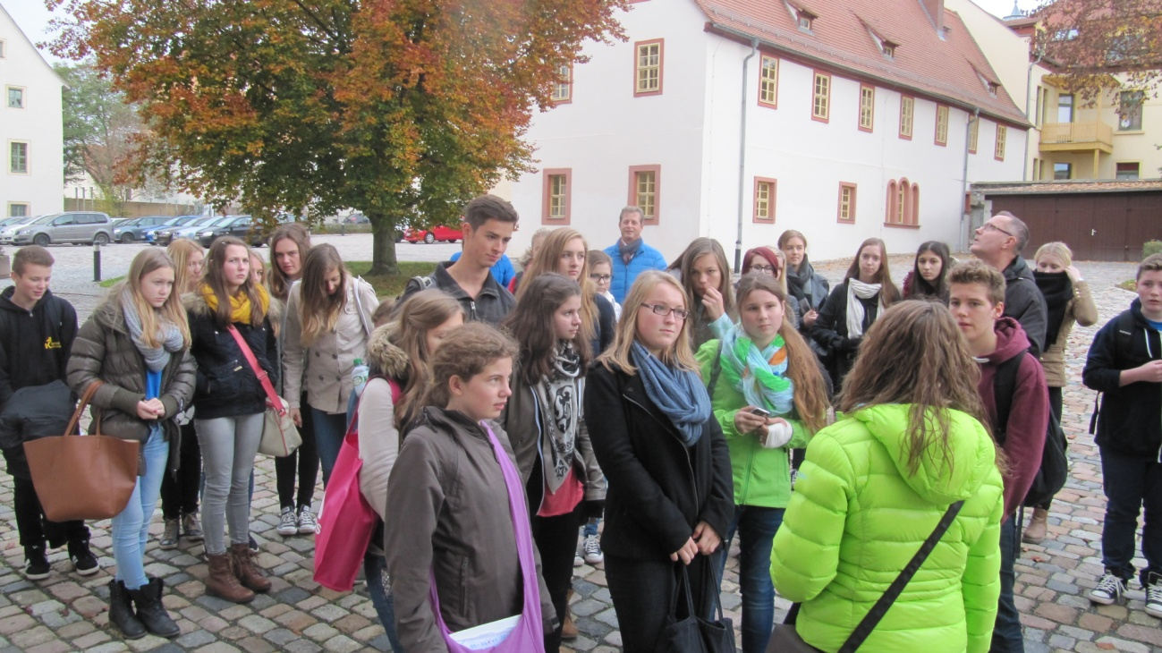

|  |
| --- |
| Dieses Projekt wurde mit Unterstützung der Europäischen Kommission finanziert. Die Verantwortung für den Inhalt dieser Veröffentlichung (Mit­teilung) trägt allein der Verfasser; die Kommission haftet nicht für die weitere Verwendung der darin enthaltenen Angaben. |